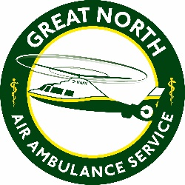
The Great North Air Ambulance Service
Person Specification
Job title: Operational Co-Ordinator
Department: Operations

 | Essential | Desirable
Qualifications / Education / Training | A good standard of general education  Current, clean, full driving licence
Personal Characteristics / Communication | Excellent team player who is also able to work independently or part of a team  Excellent interpersonal skills, to communicate with a broad range of people across a range of mediums  Excellent written and verbal communication skills  Flexible regarding working hours and able to work occasional weekends as required
Skills / Knowledge / Experience | Working knowledge of Microsoft Office packages including Excel and Word  Highly organised multi-tasker with a high level of attention to detail  Be able to work to deadlines  Able to prioritise work  Able to work under own initiative and with discretion  Logistical experience, management of stores and equipment | Experience of working with, and processing, highly sensitive data.  Experience of working in a clinical environment  Experience of working within an ambulance environment

